# A close up of a logo

# Dynamics 365 Customer Insights

Appendix A: Provision the Infrastructure

Contents

Step 1 – Office 365 Trial 3

Step 2 – Power Apps License 7

Step 3 – Power BI Trial 8

Step 4 – Dynamics 365 Marketing Trial 9

Step 5 – Customer Insights Trial 10

## Approximate Time to Complete – 30 mins

This appendix contains step-by-step instructions to provision and configure a Customer Insights environment, including prerequisites. This should only be followed if the environment has not been set up for your training session. If it has, please complete Lab 3 instead of this appendix.

**Note:** completing this lab requires enrolling in certain Microsoft cloud services using trial subscriptions. You may need to supply your own telephone number and a credit card to subscribe. To avoid charges, remember to cancel your trial subscriptions at the end of the course, or before the trial periods end (durations vary by product).

# Step 1 – Office 365 Trial

The first step in the process is to create an Office 365 tenant for your user accounts. Open an “in private” browser window and navigate to <https://aka.ms/appinadayo365signup>. Fill in your email address and click **Next**

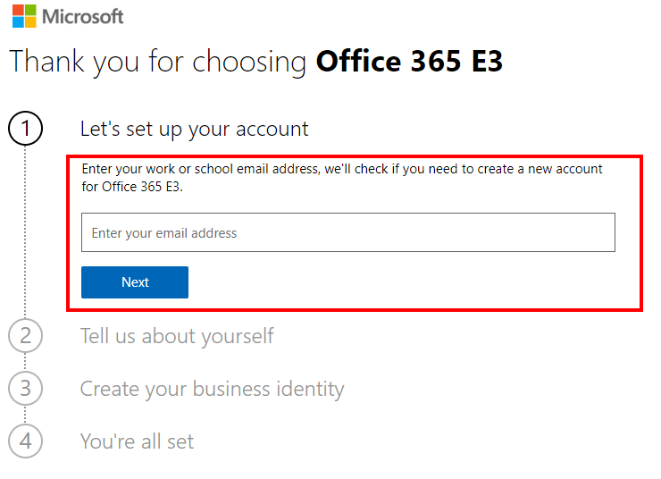

On the next screen, you will want to click on the **Create a new account instead**

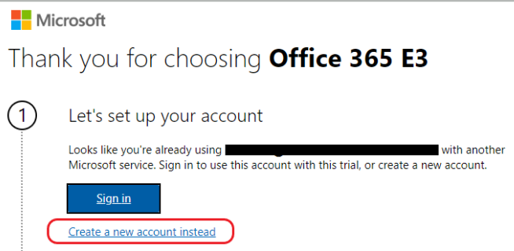

You are now able to fill in information about yourself, then click **Next**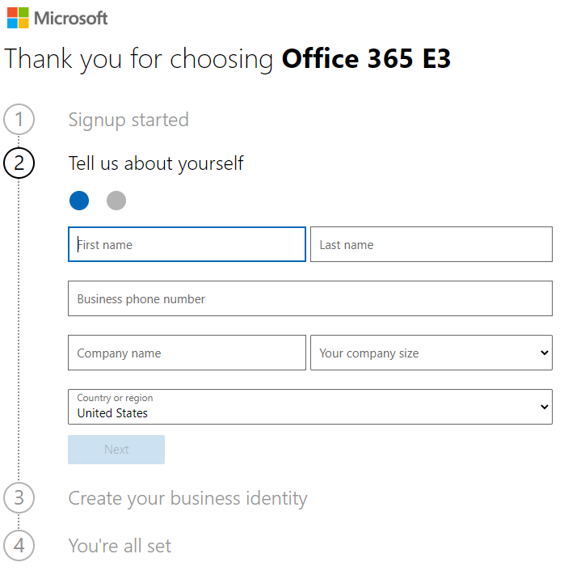

Now you will be asked for a phone number to text or call with a verification code.

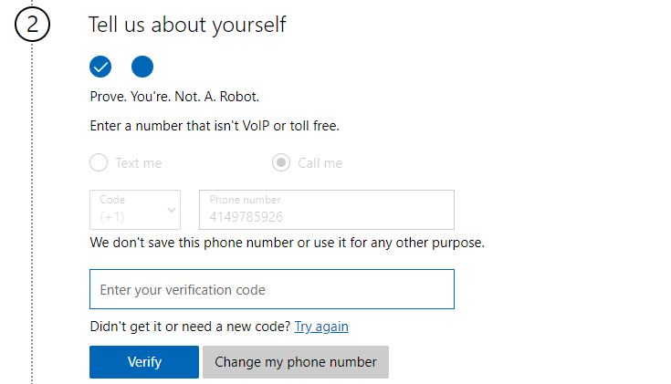

After entering the verification code and continuing you will next be able to choose your business identity. You will need to provide a company (tenant name). We suggest using something unique and personal to you, your name may work.

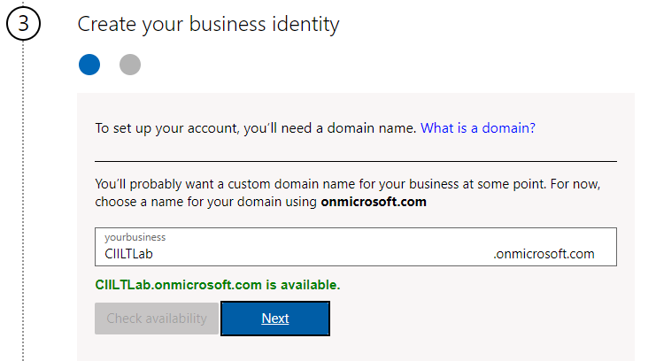

Finally, you will need to create your admin account and a password for it. We recommend using ‘admin’ for your email address as that is the account you are creating. You’ll have something like admin@CIILTLab.onmicrosoft.com for your account. When you have finished click **Sign up**.

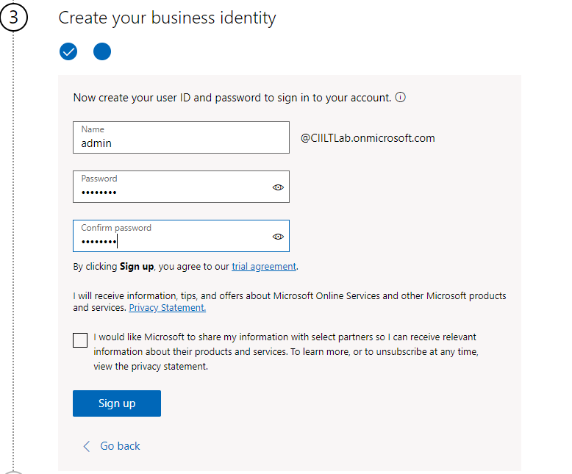

Once everything completes you will get a page like this where you can click **Go to Setup** if you’d like to setup mail or install office apps. For the purposes of this training you are done at this point and do not need to do either of those things.

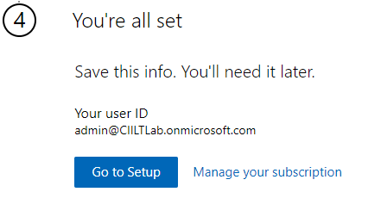

# Step 2 – Power Apps License

Now that you have a working Office 365 tenant, we will add a Power Platform trial license to the tenant. Open a new tab and navigate to <https://powerapps.microsoft.com>. On this page you will see a **Try free button** on the top right.Click that button and enter the email for the admin account you created in the last step.

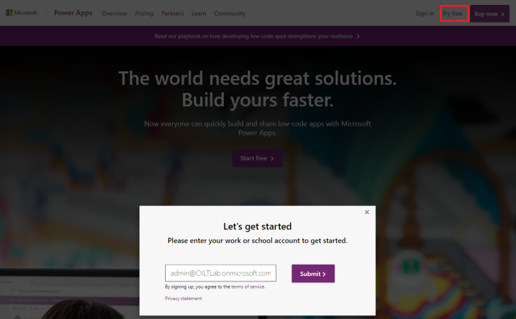

You will then get the **Almost There** screen, click the **Start** button.

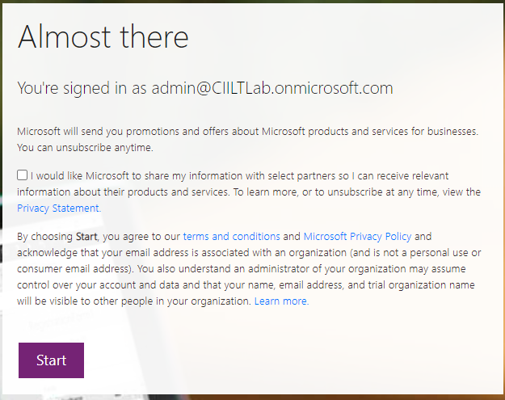

Upon clicking **Start** you will be taken to the Power apps page.

# Step 3 – Power BI Trial

You will also need a Power BI Trial to create a nice dashboard showing the information from Customer Insights. To get started navigate to <https://aka.ms/trybi> in an in-private or incognito window.

On the page enter the email for your admin account created in Step 1, like this and then click **Sign Up**.

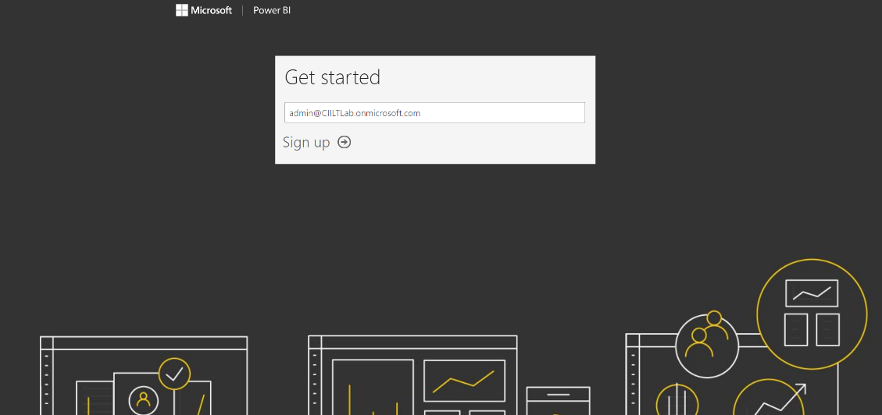

Click on the **Sign in** button and enter your password. Then click **Start**.

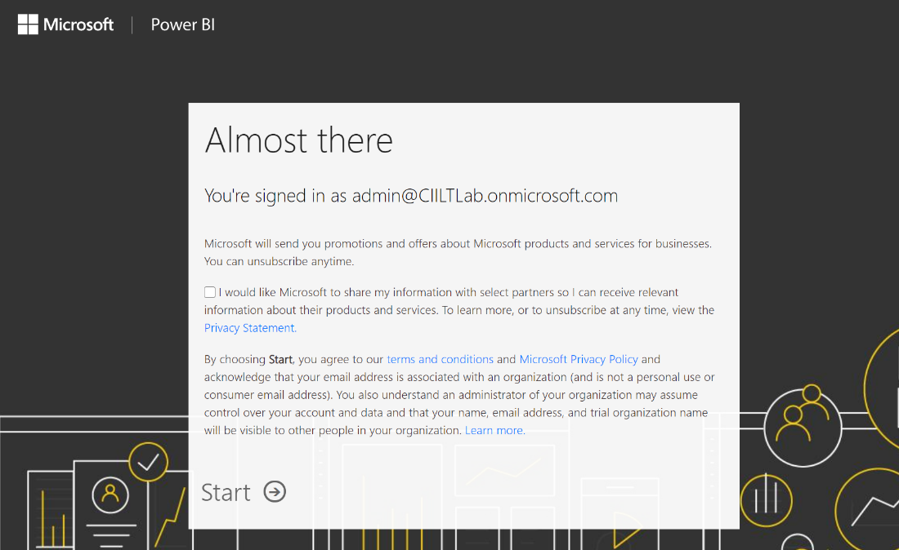

On the **Invite more people** screen you can click **Skip.** Finally, you will need to install the Power BI desktop application from here: <https://www.microsoft.com/en-us/download/details.aspx?id=55330>

# Step 4 – Dynamics 365 Marketing Trial

Now that we have users with licenses in our Office 365 tenant, we can create our demo Dynamics environments. Navigate to <https://trials.dynamics.com/Dynamics365/marketing> where you will see this page.

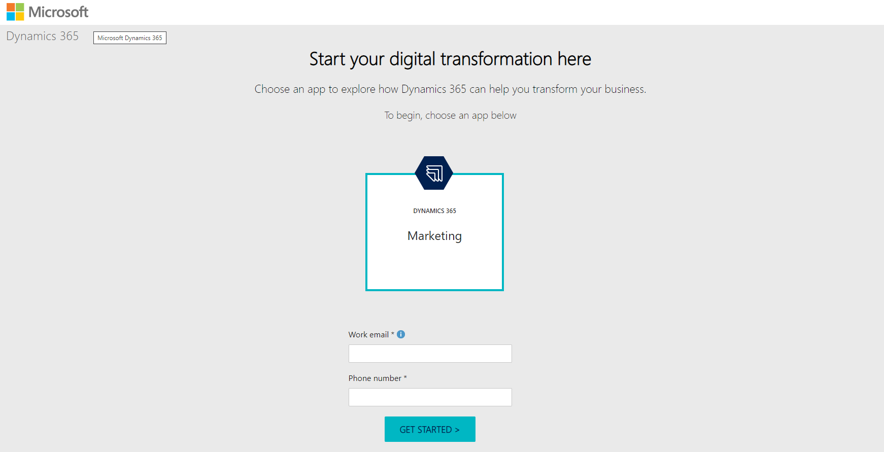

Select the **Marketing** box and then fill in the email and phone number. This should be the admin email you created in Step 1 (something like admin@CIILTLab.onmicrosoft.com). After you fill in the info and click the **Next** button, you’ll get a screen telling you that “you have an account with us, click **Sign In.** Next,you’ll have a screen asking about sharing information, simply click **Create** to move ahead.

During the setup process you may be presented with one or more **Permissions requested** screen. If so, check the **Consent on** behalf box and then click Accept. Once it has completed you will see a final consent screen check both boxes and enter any physical address then click **Get Started**.

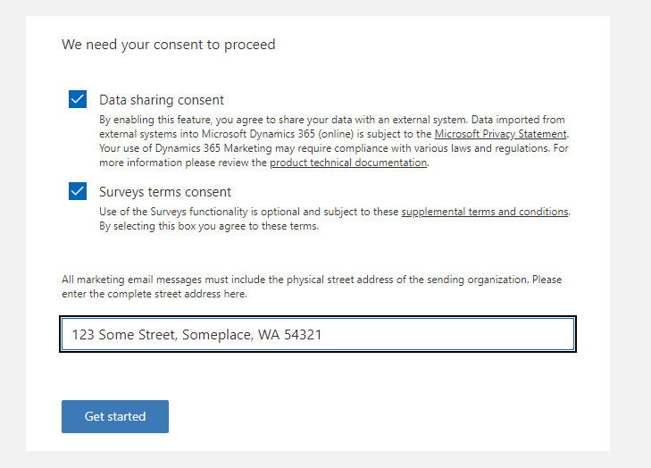

Finally, click the **Begin** button and you will be taken to the D365 Marketing application.

# Step 5 – Customer Insights Trial

Now that we have setup our Admin user, Power Apps license and Dynamics we are ready to request our Trial of Customer Insights. Open a new “in private” browser instance and navigate to <https://aka.ms/tryci>.

On the page you see, click on ‘**Yes, add it to my account’**

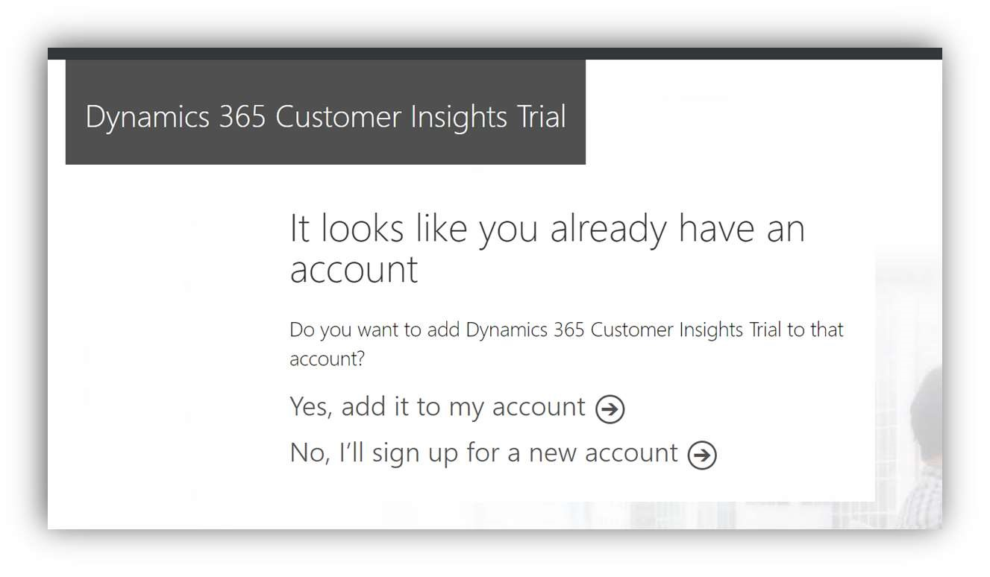

This will kick off the process to add 25 user licenses for a trial to your tenant. First, you will need to click the **Try now** button on the Confirm your Order page.

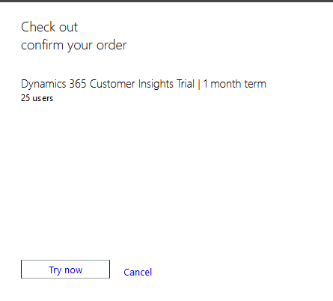

Click **Continue.** It will open the Microsoft 365 admin page. Here you need to assign CI license to the admin user you created.

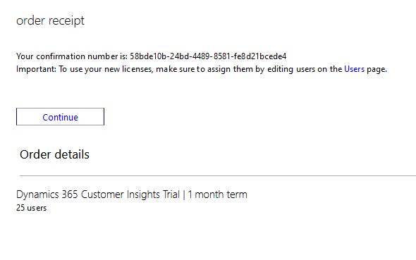

Expand the **Billing** menu option and click on **Licenses** and then click on **Dynamics 365 Customer Insights.**

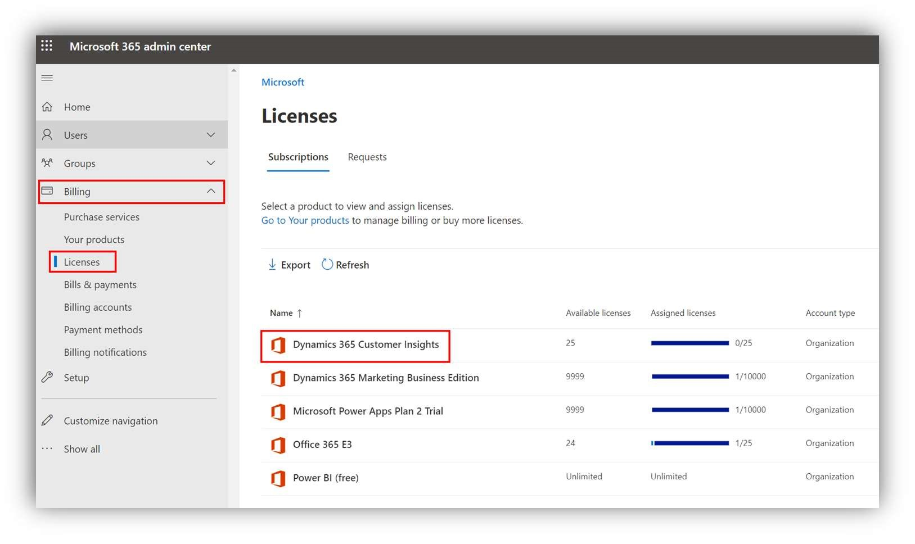

Click on +**Assign licenses.** Choose your admin account in the right pop up menu and click **Assign.**

Open https://home.ci.ai.dynamics.com/Start.

The first screen is labeled **Customize your trial**. Choose an industry to load the demo environment where you can explore all the pre-setup features and insights with the chosen industry demo data. Let’s choose **Retail** and review the terms and conditions and click **Continue.**

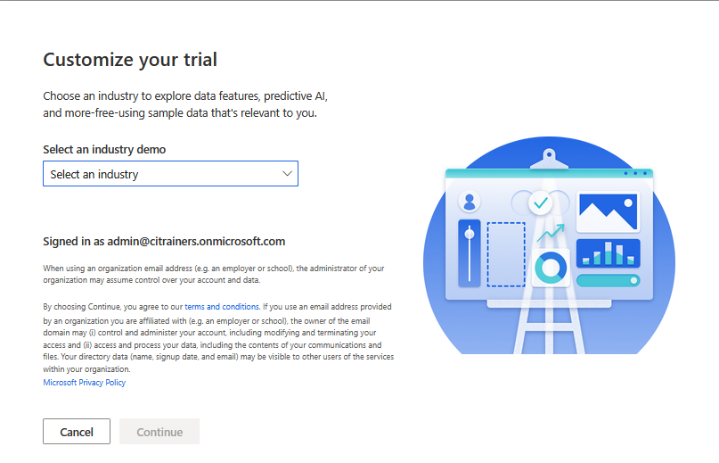

Next you will create the environment. We suggest you name it CI ILT Lab. Once you enter the name and select the region you can click **Create**.

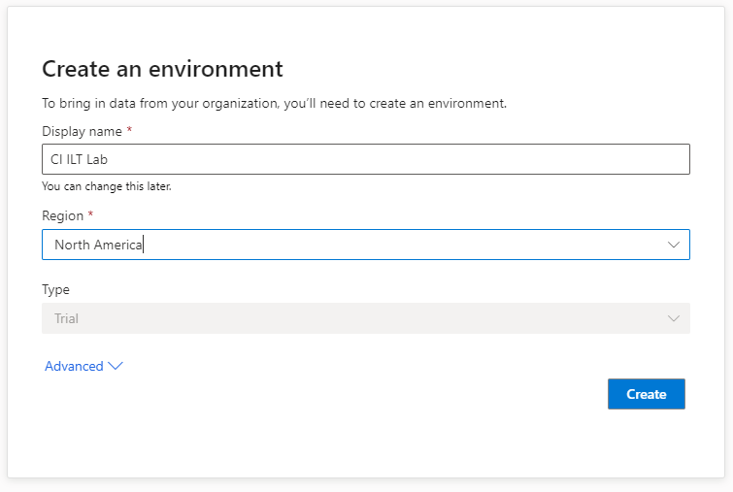

Once it completes you will be at the landing retail demo page for Customer Insights. Switch to your environment by clicking on top right at **Environment** and you are good to start on the labs.

